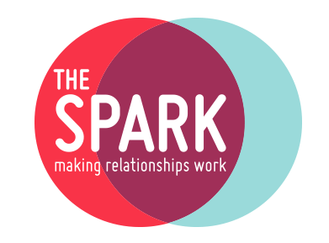

Cognitive Behavioural Therapy Approach (CPD)

Booking Form

Please complete and return to The Spark at [training@thespark.org.uk](mailto:training@thespark.org.uk)

|  |  |
| --- | --- |
| Name: |  |
| Contact number: |  |
| Email: |  |
| Billing address & postcode: |  |
| Your current workplace and role, or volunteering role etc. |  |
| Any access or learning requirements: *If yes, please note that we will be in touch via email for any reasonable adjustment requests. |  |

**ATTENDANCE**

This 12-hour CPD workshop is delivered over two days. Participants must attend both training days of the course and will be issued with a certificate upon completion.

**HOW DID YOU HEAR ABOUT US?**

|  |  |  |  |  |  |
| --- | --- | --- | --- | --- | --- |
| Search Engine |  | Advert |  | Social Media |  |
| Word of Mouth |  | Employer |  | Other |  |
| If other (please comment): | |  | | | |

|  |  |  |  |
| --- | --- | --- | --- |
| Name: |  | Date: |  |
| Please tick the box to confirm that you have read our terms and conditions before submitting your application: | | |  |

**TERMS & CONDITIONS**

Please note that when you make your application, you are agreeing to the following terms and conditions:

**Course Fee**

* The advertised course fee includes 12 hours of training and a certificate on successful completion of the course.
* If you wish to withdraw from the course, please inform us no later than 2 weeks before the first training day. We will refund any payments made for training days not yet begun less a £25 administration fee.
* If the course is cancelled by The Spark, we will refund the full fee. We are unable to reimburse out-of-pocket expenses, such as for travel or accommodation.

**Liability**

We are not responsible for items that are lost or stolen during our course and workshops.

**Privacy Notice**

We collect your personal and sensitive personal data to process your application, assess your suitability for training, record attendance, and note assessment scores where relevant. Your personal data will also be shared with COSCA to register you for courses accredited or registered by them. Please see our [**Privacy Policy**](https://thespark.org.uk/about-us/legal-stuff/privacy-policy/) for details of 3rd party suppliers we may share your data with, how long we will retain your data and the rights you have in relation to your personal data.

**Registered Charity No. SC 018249**